CO1-AT2
Course Code: DSA0502 Course Name: Query Processing For Data Science

18. Employee payroll details are stored in payroll.csv.
Task:
● Calculate gross salary.
● Calculate net salary after deductions.
● Find employees earning above ₹75,000.
● Save the updated payroll.
Code:
import pandas as pd
data = {
"Employee_ID": [101, 102, 103, 104, 105],
"Employee_Name": ["Arun", "Bala", "Cathy", "Dinesh", "Elan"],
"Basic_Salary": [40000, 60000, 50000, 80000, 70000],
"Allowance": [5000, 10000, 8000, 15000, 12000],
"Deduction": [3000, 5000, 4000, 8000, 6000]
}
df = pd.DataFrame(data)
# Save original payroll data
df.to_csv("payroll.csv", index=False)
df["Gross_Salary"] = df["Basic_Salary"] + df["Allowance"]
df["Net_Salary"] = df["Gross_Salary"] - df["Deduction"]
# Find employees earning above ₹75,000
high_salary = df[df["Net_Salary"] > 75000]
df.to_csv("updated_payroll.csv", index=False)
print("Updated Payroll:")
print(df)
print("\nEmployees earning above ₹75,000:")
print(high_salary[["Employee_ID", "Employee_Name", "Net_Salary"]])
print("\nUpdated payroll saved as updated_payroll.csv")

OUTPUT:
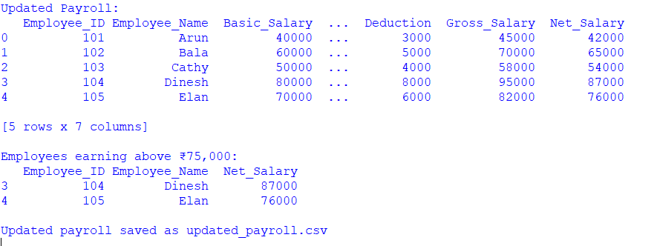

19. Smart City Traffic Data
Traffic information is stored in traffic.csv.
Task:
● Calculate average daily traffic.
● Find roads with the highest congestion.
● Display accident-prone locations
Python Code:
import pandas as pd
data = {
"Road": ["Anna Nagar Road", "OMR Road", "Mount Road", "GST Road", "ECR Road"],
"Daily_Traffic": [5000, 8000, 7500, 6000, 4000],
"Congestion_Level": [3, 5, 4, 2, 1],
"Accidents": [2, 5, 4, 1, 3],
"Location": ["Anna Nagar", "Sholinganallur", "Guindy", "Tambaram", "ECR"]
}
df = pd.DataFrame(data)
df.to_csv("traffic.csv", index=False)
average_traffic = df["Daily_Traffic"].mean()
highest_congestion = df[df["Congestion_Level"] == df["Congestion_Level"].max()]
accident_prone = df[df["Accidents"] >= 4]
print("Average Daily Traffic:", average_traffic)
print("\nRoads with Highest Congestion:")
print(highest_congestion[["Road", "Congestion_Level"]])
print("\nAccident-Prone Locations:")
print(accident_prone[["Location", "Accidents"]])

OUTPUT:
